DiceRollingGame

*A*

*Project Report*

### *Submitted*

### *In Partial fulfillment*

### *for the award of the Degree of*

### ***BACHELOR OF COMPUTER APPICATION***

### University_of_Rajasthan_logo.gifSubodh_College_Logo.jpg**Department of Computer Science**

|  |  |
| --- | --- |
| **Submitted to   BCA** | **Submitted by  Name: Narsi Gurjar Roll No.: 1742127** |

### **S. S. Jain Subodh P. G. (Autonomous) College**

### Affiliated to

### **University of Rajasthan, Jaipur**

**B. C. A.**

**2019**



**CERTIFICATE**

This is to certify that Narsi Gurjar was under training from 25/02/2019 to 24/05/2019 in my supervision in partial fulfillment of the requirement for the award of the Degree of Bachelor of Computer Applications.

During the period he/she has worked on Android Application Development/ PHP platform.

Date : Training Incharge

**ACKNOWLEDGEMENT**

First of all, I would like to offer our heartiest gratitude to **Mr. RITESH JAIN** for all the help and encouragement that they rendered to me during the course of this project. Indeed, it was your support & effort that lead us through the cloudy skies & muddy waters towards the successful completion of this project.

Also, a special thanks to my internal guide **MR. VIPIN SIR** Indore for this support and valuable time.

I would like to thank my friends and my team members for being a constant source of encouragement in all my endeavors. Indeed, it was your support that saw us through the many ups and down of life.

Narsi Gurjar

**TABLE OF CONTENTS**

**ABSTRACT**

**1. GENERAL INTRODUCTION**

1.0 Introduction

1.1 Problem Statement

1.2 Objectives of the study

1.2.1 Main Objectives

1.2.2 Specific Objectives

1.3 Scope

1.4 Significance of the Study

**2. METHODOLOGY**

2.1 System Implementation

2.2 System Testing and Validation

2.3 Development of the System

**3. SYSTEM ANALYSIS AND SYSTEM DESIGN**

3.1 System Requirements

3.2 System Design

3.3 Logical Design

3.4 Entity Relationship Diagram

**4. SYSTEM IMPLEMENTATION AND TESTING**

4.1 Introduction

4.1.1 User Requirement

4.1.2 Functional Requirements

4.1.3 Non-Functional Requirement

4.1.4 Software Requirements

4.2 System Implementation

4.3 System Test

4.3.1 Unit Testing

4.3.2 Integration Testing

4.3.3 System Validation

4.4 Presentation of Result

4.4.1 System Interface

4.4.2 DiceRollingGame Main Page

4.4.3 DiceRollingGame Result Pages (DRGRPs)

4.4.4 Database of DiceRollingGame created from phpmyadmin

**5. CONCLUSION**

**ABSTRACT**

Dice Rolling a game mechanic dice rolling in a game can be used for many things, randomness being the most obvious. Dice can also be used as counter start at 6 and turn it to 5 at the end of round, single player’s turn etc.

Normally games require little bit high space for playing games but this game is light that it online game that run each and every handheld device with normal space. It does not require any additional memory or space as it is small enough that any browser be able to play this game. Dice rolling is a board game it will be play by two players.

1. **GENERAL INTRODUCTION**

# **Introduction**

Most of us are familiar with dice through board games such as Snakes and Ladders, Ludo or Monopoly. These games use traditional cubic dice with the six faces numbered so that opposite faces add up to 7. There are many other types of dice - with 4, 8, 10, 12 and 20 sides, and even left-handed dice!

If you throw a normal six-sided dice then in the long run you expect to get equal numbers of 1’s, 2’s, and 3’s and so on. But what happens in the short run? The first of our Excel spreadsheets allows you to investigate what can happen. The computer has been programmed to throw dice just like the real thing – we call it a simulation.

# **Problem Statement**

For my final project I choose to write a program for the dice game “DiceRollingGame”. I choose this game since I am aware of the rules and have played it a few time. I needed a program that can take 2 players, and roll from 1 to 6 random dice, and score the rolled/rerolled dice. It will also need to store the players’ names and their score, as well as add each round score to the player score, and carry over round scores after a player passes.

# **Objectives**

# **Main Objectives**

# Our major objective is to develop a DiceRollingGame for general public to access this game to play with friend make some fun.

# **Specific Objectives**

# To create a dice rolling game for user who want game that run as online and choice winning-score.

# To display the the panel of game play result.

# To make sure the websites/webpages are ranked according to number of visitors

# To implement the system

# To test and validate the system

# **Scope**

We have looked into the fun of play DiceRolling game and its design and implementation (integration of modules too). For gaining an insight into how the DiceRollingGame Site works, a comparative study of various features the several dice game site offer have been made.

# **Significance**

This phrase originated from the advent of gambling using a six sided die. So when people roll the dice, they hope to get a number, usually number 7, and then win some money. If they don’t get this number, they lose whatever money they had put on the game and get a chance to pay to play again. So the phrase became used in everyday life as taking a chance or a risk to get something worthwhile.

A traditional die is a cube with each of its six faces marked with a different number of dots (pips) from one to six. When thrown or rolled, the die comes to rest showing on its upper surface a random integer from one to six, each value being equally likely. Dice may also have polyhedral or irregular shapes and may have faces marked with numerals or symbols instead of pips. Loaded dice are designed to favor some results over others for cheating or entertainment.

# **2.** **METHODOLOGY**

# **2.1** **System Implementation**

# This describes the tools used to implement the graphical user interface and the database. MySQL was used to create and connect relational tables to the database. HTML, CSS and JavaScript was used to develop the GUI. PHP was used to process queries and interfaces was done to develop the model that meets all the requirements of this system and dialogflow was used to chat with user**.**

# **2.2 Systems Testing and Validation**

# Testing was done after the system was put in place. This was done in two ways:

# Implementation and Unit testing was carried out on individual modules of the system to ensure that they are fully functional units. We did this by examining each unit which we checked to ensure that it functions as required and that it adds client’s data and other details and also ensured that this data is sent to the database. The success of each individual unit gave us the go ahead to carryout integration testing. All identified errors were dealt with

# As one of the final specific objectives of this study, validation of the system was important. Validation of the system was done by comparing it to the questions asked by the general users and analyzing the existing engines. Most of the outcomes matched what the system can do.

**2.3 Development of the System**

This section describes what is evolves to come up with the system and how the system works.

**Front end:** HTML, CSS and JavaScript are enable the construction of easy and intuitive user interface for accessing the database and any browser can display and html document.

**Middle end:** PHP enables links of the text entered in the created graphic user interface to be sent to the database.

**Back end:** MySQL it’s easy to use, inexpensive database language it can run on a variety of operating system such as Window, Linux, Unix and others, its secured with technical support widely available on the internet but most of all it supports large database.

# **3. SYSTEM ANALYSIS AND SYSTEM DESIGN**

# **3.1 System Requirement**

# This section describes the hardware components and software requirements needed for effective and efficient running of the system.

# Table: Hardware Requirement

|  |  |
| --- | --- |
| **Hardware** | **Minimum System requirement** |
| Processor | 2.4 GHZ processor speed |
| Memory | 2 GB RAM (4 GB  Recommended) |
| Disk space | 80 GB (including 20 GB for database  Management system) |
| Display | 800 x 600 colors (1024 x 768 High  color- 16 bit Recommended) |

# The table above shows hardware components of the machine that allows the system to function as required for using DiceRollingGame.

# Table: Software Requirements

|  |  |
| --- | --- |
| **Software** | **Minimum System requirement** |
| Operating System | Windows2000 or later |
| Database Management System | MYSQL |
| Browser | Chrome |
| Run-time Environment | Apache |

# The table above shows software requirements recommended to enable the system to run as required for using DiceRollingGame.

# **3.2 System Design**

# After interpretation of the data, tables were drawn and process of data determined to guide the researcher of the implementation stage of the project. The tools, which were employed during this methodology stage, were mainly tables, Data Flow Diagrams (DFDs) and Entity Relationship Diagrams (ERDs). The design ensures that only allows authorized users to access the system’s information.

# **3.3 Logical Model**

# This figure shows the logical flow of events in the system.

# 

# Figure: Logical flow of data in DiceRollingGame

**3.4 Entity Relationship Diagrams**

Entity Relationship diagrams is a specialized graphics that illustrate the interrelationship between entities in a database. Here diagrams always use symbols to represent different types of information.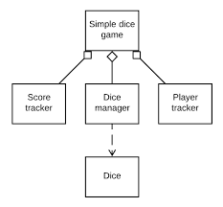

# Figure: Entity Relationship Diagram

# The diagram above is an entity relationship diagram that is a major data modeling tool that helped database analysts to organize data into entities.

**4. SYSTEM IMPLEMENTATION AND TESTING**

# **4.1 Introduction**

# This chapter emphasizes the actual system implementation. The system was transformed from user requirement into a workable product. The purpose of system implementation was to make sure that the correct application is delivered to the end user. Besides that, this chapter also emphasizes on how the testing is done to confirm to meets the user requirement.

# **4.1.1 User Requirement**

# The users described some of the basic requirements of the system as;

# First player name.

# Second player name.

# Winning-Score.

**4.1.2 Functional Requirement**

* The first alert message is “Enter player first name” that required first player name.
* The second alert message is “Enter player second name” that required second player name.
* The third alert message is “Enter winning-score” that required Winning-Score.

**4.1.3 Non-Functional Requirement**

* The system should must verify and validate all user input and users must be notified in case of errors detected in the course of using the system.
* A system should have a high performance and reliability level.

# **4.1.4 Software Requirements**

# **PHP (hypertext preprocessor)**

# **PHP** is a server-side scripting language designed specifically for the web. The goal of the language is to allow web developers to write dynamically. PHP allows interfacing too many different database systems that provides an open database connectivity standard (ODBC) such as. MySQL, Oracle, Microsoft products and others. Other advantages are low cost and availability. PHP is portable across multiple platforms and is created as an open-source.

# **MySQL (My Structured Query Language)**

# **MySQL** is an open source relational database management system (RDBMS) that uses Structured Query Language (SQL), the most popular language for adding, accessing, and processing data in a database. MySQL is noted mainly for its speed, reliability, and flexibility. It is fast, robust and scalable relational database management system. My SQL is a true multi-user, multi-threaded SQL (structured programming language) database server.

# **Apache web server**

# The **apache** web server is the software that responds to client requests by providing resources, such as XHTML documents. Apache has other powerful features included in a large set of modules, including mod Perl, and many authentication modules.

# **Dialogflow**

**Dialogflow** is Google-owned developer of human-computer interaction technologies based on natural language conversations.

# **JavaScript**

**JavaScript** is an object-oriented scripting language used to enable programmatic access to objects within both the client application and other applications. It is primarily used in the form of client-side JavaScript, implemented as an integrated component of the web browser, allowing the development of enhanced user interfaces and dynamic websites. JavaScript is a dialect of the ECMAScript standard and is characterized as a dynamic, weakly typed, prototype-based language with first-class functions.

**4.2 System Implementation**

This describes the tools used to implement the graphical user interface and the database. MySQL was used to create and connect relational

Tables to the database. HTML was used to develop the GUI. PHP was used to process queries and integrate interfaces was done to develop the model that meets all the requirements of this system and dialogflow api useto build ai chat bots for given answer that asked by user.

**4.3 Systems Test**

Testing was done after the system was put in place. This was done in two ways namely Unit Testing and integration testing.

**4.3.1 Unit Testing**

Unit testing was carried out on individual modules of the system to ensure that they are fully functional units. We did this by examining each unit, for example the Underwriter’s page. It was checked to ensure that it functions as required and that it adds patient’s data and other details and also ensured that this data is sent to the database. The success of each individual unit gave us the go ahead to carryout integration testing. All identified errors were dealt with.

**4.3.2 Integration Testing**

We carried out integration testing after different modules had been put together to make a complete system. Integration was aimed at ensuring that modules are compatible and they can be integrated to form a complete working system. For example, we tested to ensure that when a user is logged in, he/she is linked to the appropriate page, and also could access the database.

**4.3.3 System Validation**

As one of the specific objectives of this study, validation of the system was very important. Validation of the system was done by comparing it to the questions asked by the users at the institutions. Most of their answers matched with what the system can do. JavaScript was used to validate user input and respective input. For example, the system does not accept blank field; the system also discriminates between numerical and non-numerical characters.

**4.4 Presentation of Results**

The presentation of the results of DiceRollingGame is analyzed in terms of the interfaces of the system and output from the backend of the system. This includes activities of the users. The following are the results after the implementation of the DiceRollingGame.

**4.4.1 System Interfaces**

All system interfaces in this chapter were created using DreamViewer and while creating HTML and PHP interfaces.

**4.4.2 DiceRollingGame Main Page**

The DiceRolling allows the user to input the both two player for play this game

And with winning-score.

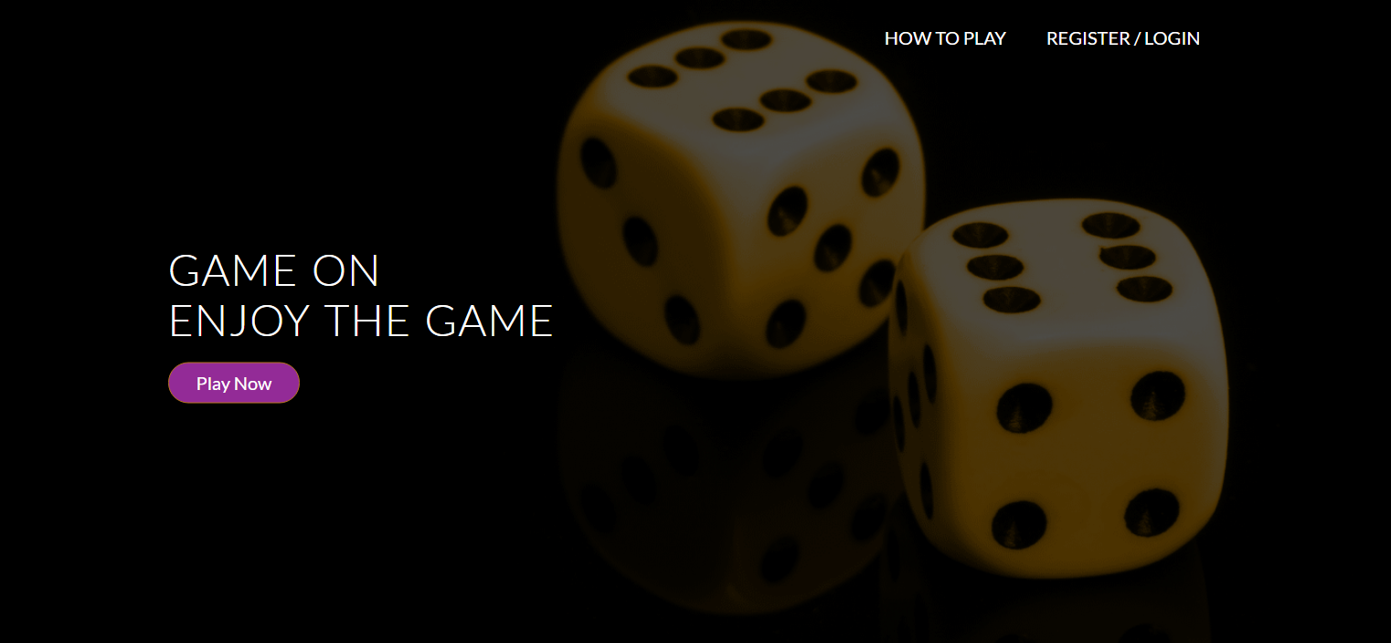

**Figure: Main page for the DiceRollingGame**

**4.4.3 DiceRollingGame Result Pages (DRRPs)**

The result page of DiceRollingGame show both play name and current score for win the match that equal and greater than winning-score.

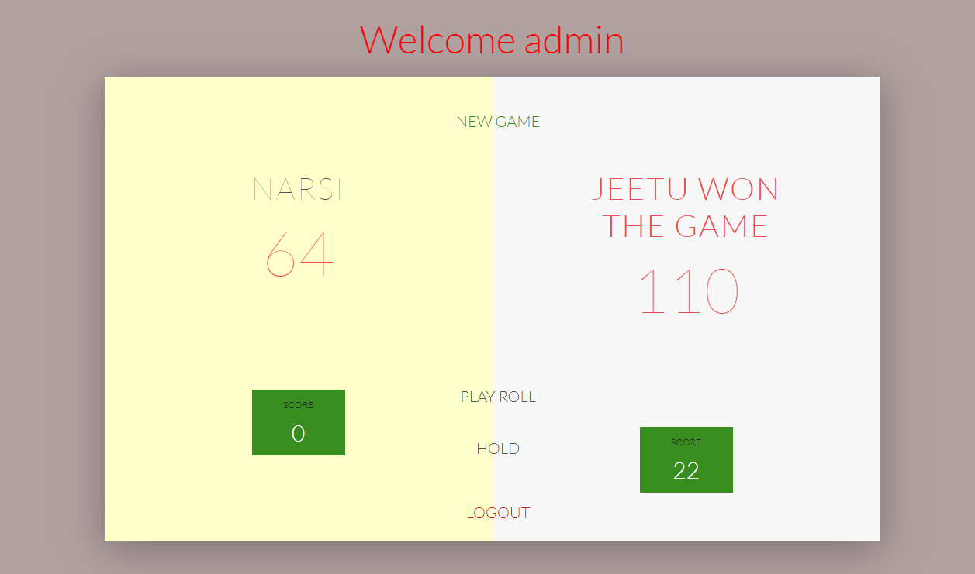

**Figure: DRRPs showing results for Game**

**4.4.4 Database of DiceRollingGame imported in phpMyAdmin**

The system cannot run unless XAMPP server is installed in the machine (laptop or computer) then the system database is created and imported from where it’s saved to the phpMyAdmin.

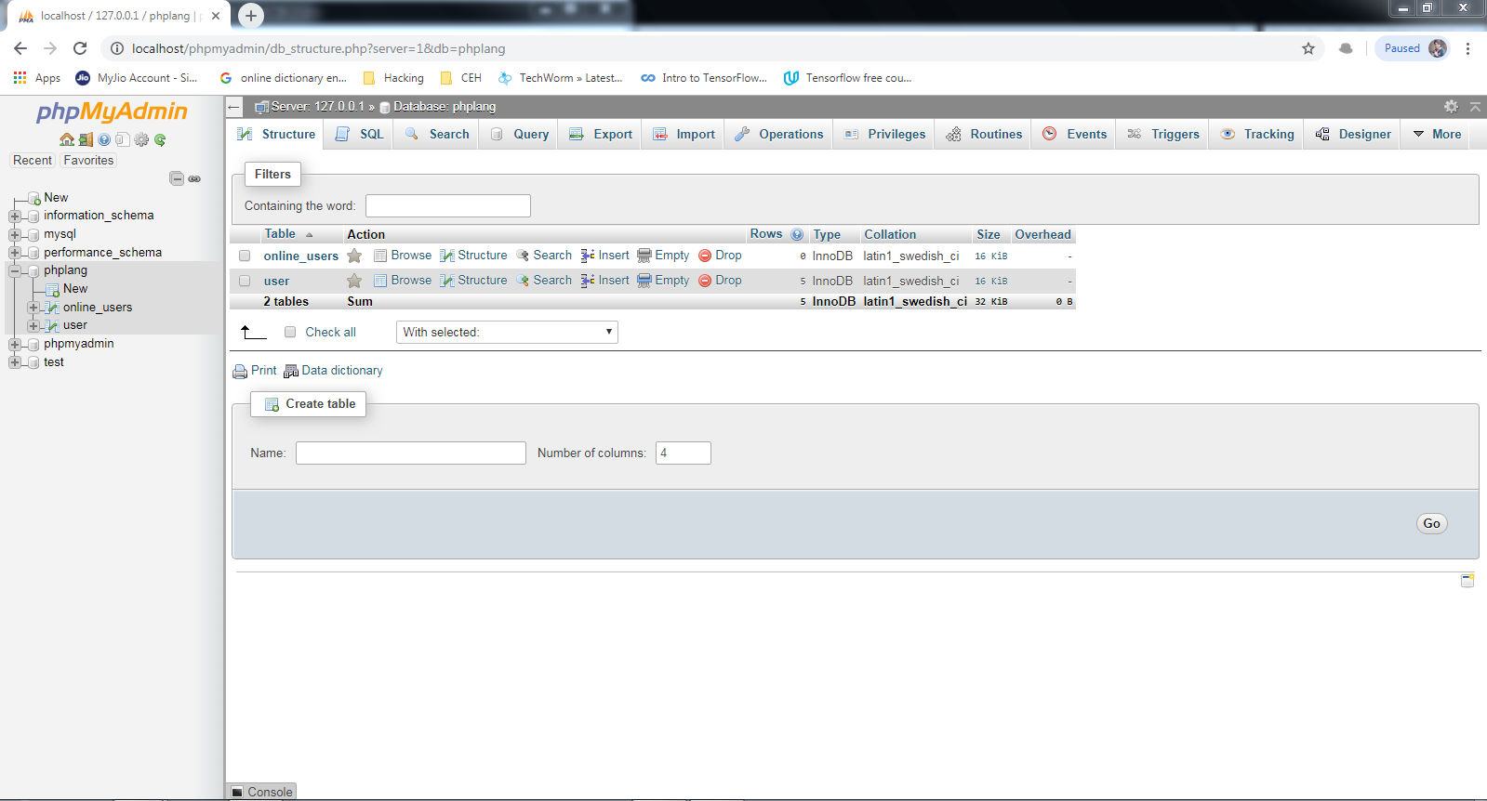

**Figure: Database of DiceRollingGame imported from phpMyAdmin**

1. **CONCLUSION**

The game is relatively quick and simple. It is highly luck based as the only strategy are the limited items that you may or may not get. It is thankfully a very short game, since it’s possible for one person to get a sizable lead and no one can catch them.